Data Structures and Algorithms  **Assignment 6**

1. What exactly is an application tree?

* Storing naturally hierarchical data: Trees are used to store the data in the hierarchical structure. For eg, the file system. The file system stored on the disc drive, the file and folder are in the form of the naturally hierarchical data and stored in the form of trees.
* Organize data: It is used to organize data for efficient insertion, deletion and searching. For example, a binary tree has a logN time for searching an element.
* Trie: It is a special kind of tree that is used to store the dictionary. It is a fast and efficient way for dynamic spell checking.
* Heap: It is also a tree data structure implemented using arrays. It is used to implement priority queues.
* B-Tree and B+Tree: B-Tree and B+Tree are the tree data structures used to implement indexing in databases.
* Routing table: The tree data structure is also used to store the data in routing tables in the routers.

2. What is pre-order tree traversal and how does it work?

Pre-order traversal is one of the many ways to traverse a tree. It is mainly used when a tree needs to be duplicated.

Algorithm is :

1. Visit the root
2. Recursively traverse the left subtree
3. Recursively traverse the right subtree

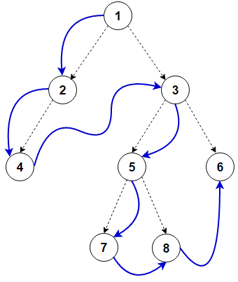

In above eg. root is 1, then go left means 2, then go left means 4, now go to root that is 3 the go to left means

5, go to left means 7, go to right 8, go to right so 6

so the answer for preorder would be 1 2 4 3 5 7 8 6

3. What is the problem with the Hanoi Tower?

* The Tower of Hanoi is a mathematical problem which consists of three rods and multiple disks.
* Initially, all the disks are placed on one rod, one over the other in ascending order of size similar to a cone-shaped tower.
* The objective of this problem is to move the stack of disks from the initial rod to another rod, following these rules:
* A disk cannot be placed on top of a smaller disk
* No disk can be placed on top of the smaller disk.
* The goal is to move all the disks from the leftmost rod to the rightmost rod. To move N disks from one rod to another, 2^𝑁−1 steps are required. So, to move 3 disks from starting the rod to the ending rod, a total of 7 steps are required.

4. Can you explain the distinction between linear and nonlinear data structures?

|  |  |
| --- | --- |
| **Linear** | **Non Linear** |
| A linear data structure is a data structure that has data elements in sequential order. | Non Linear data structure stores data in a non-sequential manner. |
| Array, Linked List, Stack, and Queue are some common examples of linear data structures | Trees and graphs are the most common nonlinear data structures. |
| We can insert/delete elements in sequential orders | It is not possible to insert elements, delete elements or go through the elements in sequential order |
| Memory utilization is inefficient | Memory utilization is efficient |
| Easier to implement | Difficult to implement |
| Single level | Multi level |

5. What is the distinction between a list and an array

|  |  |
| --- | --- |
| LIST | ARRAY |
| It contain elements of multiple data types | It contains same data type |
| only allows sequential access to its elements | allow random access to the elements contained within them |
| used for large lists of data where the total number of items in the list is changing | better suited for small lists of data |
| There will be only used memory | There can be unused memory(used+unused) |
| Cannot directly handle arithmetic operations | Can directly handle arithmetic operations |
| Can be nested to contain different type of elements | Must contain either all nested elements of same size |
| Consume larger memory for easy addition of elements | Comparatively more compact in memory size |
| There is no need to explicitly import a module for declaration | We need to explicitly import a module for declaration |
|  |  |